Patient Information:

Name:___________________________________________________ Phone Number:_(_________)______________________

Address:______________________________________________________________________________________________________

City/State:____________________________________________ Email:_______________________________________________

Occupation: __________________________________________ Referred by:_________________________________________

Patient Agreement:

Thank you for choosing Everett Physical Therapy. I look forward to working with you to meet your rehab goals.

Consent for Treatment:
I agree to have Julie Everett, DPT evaluate and treat my condition. I understand that there are some applied risks with treatment. Absent an emergency, if the proposed treatment has increased risk, then additional informed consent will be obtained.

Payment for Services:
I understand that this is a fee for service and I will pay Julie Everett, DPT directly. The cost of session is $150/hour and payment will be paid at the time of services. Everett Physical Therapy does not guarantee reimbursement from insurance company however; I will be provided a receipt of payment and EOB so I can attempt reimbursement from my insurance company. There will be a $25 charge for any returned checked.

Cancellation/No-show Policy:
In order to achieve optimal outcomes your participation is an essential and vital component. Below we adhere to the following cancellation and no-show policy:

- Treatments start at designated appointment times so please arrive on time to maximize individualized sessions.

- If you must cancel your appointment, please give 24-hour notice via phone call or email, otherwise a $50 dollar cancellation fee will be applied.

- No-shows will be charge a $50 dollar fee.

Consent for Filming or Video Taping:
I agree to allow photographing/videotaping of me for internal education and quality improvement. (If you don’t agree, please cross out with single line, initial and date.)

By signing below I am agreeing to comply with the above policies.

Signature:__________________________________________________________ Date: ____________________________
Patient Intake Form

In order to give you the best care possible, please take a moment to fill out the following information so we can better target your evaluation and treatment sessions. Thank you.

Impairment:
What is your current impairment that is causing you to seek services: _________________________________

_________________________________________________________________________________________________________________

When did this start:____________________________________ Pain (0= no pain , 10=extreme pain):___________

What makes it worse:_____________________________ What makes it better: _________________________________

Have you had treatment/intervention for this: YES NO Details: ________________________________

Please mark where you are currently experiencing pain/discomfort:

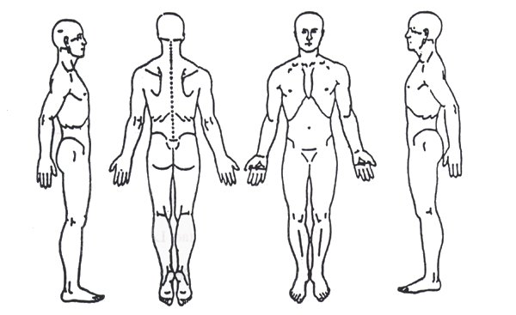

Medications:
Please list all medications you are currently taking: _____________________________________________________

_________________________________________________________________________________________________________________

Please list allergies we need to know about: ______________________________________________________________

Medical History:
Have YOU ever had any of the following:
YES / NO Cancer: If yes please describe: __________________________________________________________________

YES / NO High Blood Pressure YES / NO Osteoporosis YES / NO Heart Disease
YES / NO Circulation Problems YES / NO Asthma YES / NO Heart Problems
YES / NO Neurologic Condition YES / NO Diabetes YES / NO Blood clots
YES / NO Joint Replacement YES / NO Pacemaker YES / NO Depression
Medical History Cont.:
Please list previous surgeries/procedures: ______________________________________________________________

________________________________________________________________________________________________________________

Do you smoke? YES / NO How much?: __________________________

Do you drink? YES / NO How much?: __________________________

Are you experiencing any of these NEW or ATYPICAL symptoms that your medical doctor is NOT aware of?
YES / NO Weight loss/gain YES / NO Fatigue YES / NO Weakness
YES / NO Nausea/vomiting YES / NO Easy bruising YES / NO Tremors
YES / NO Numbness/tingling YES / NO Night sweats YES / NO Skin Rash
YES / NO Problems sleeping YES / NO Swelling YES / NO Cough
YES / NO Excessive bleeding YES / NO Heart racing YES / NO Seizures
YES / NO Fever/chills/sweats YES / NO Lightheadedness YES / NO Dizziness

Other:

Are you currently working with a KS trainer? YES NO If so, who?: ________________________________

What is your current exercise routine? ___________________________________________________________________

What are your hobbies? ____________________________________________________________________________________

What are your therapy goals? _____________________________________________________________________________

Please use the space below to share any further information with us:

______________________________________________________________________________________________________________

______________________________________________________________________________________________________________
______________________________________________________________________________________________________________
______________________________________________________________________________________________________________
Patient Signature: _________________________________________________________ Date: ______________________

Practitioner Signature: ____________________________________________________ Date: ______________________

